GI For Kids Pediatric Gastroenterology and Nutrition Services
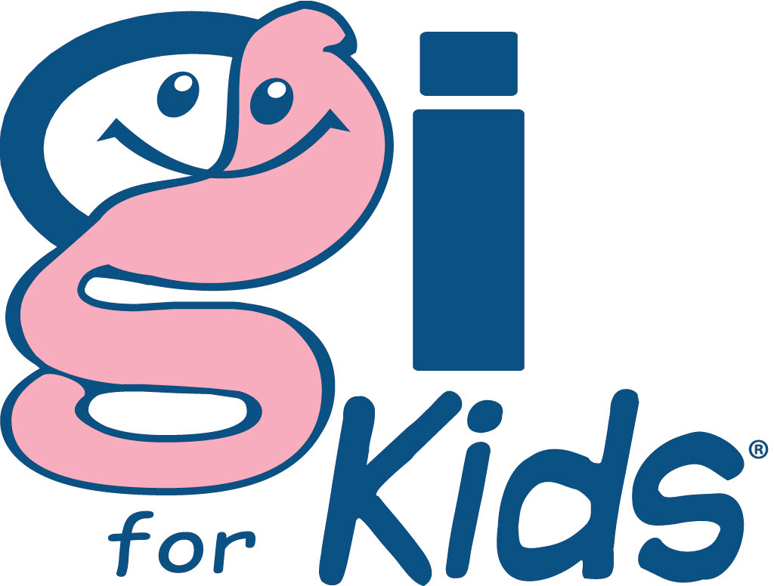
Excellent Care Every Time
1975 Town Center Blvd ∙ Knoxville, TN 37922
Phone (865) 546-3998 ∙ Fax (865) 546-1123 ∙ www.giforkids.com
Consent for Capsule Endoscopy

Name: __________________________

DOB: ____/____/________

Capsule endoscopy is a procedure used to examine the entire small intestine. The capsule contains a tiny camera that captures high-resolution, 360-degree images, which are later reviewed by a physician on a computer. The physician will then provide a detailed report, including images and an interpretation of the results.

I, ___________________________, parent or guardian of the above-named patient, understand that, although rare, there are potential risks associated with capsule endoscopy. These risks include bowel obstruction, which may require urgent surgical intervention. The gastroenterology provider at GI for Kids, PLLC has explained the procedure, including its purpose, potential benefits, risks, and alternative diagnostic methods. I have had the opportunity to ask questions and have received satisfactory answers regarding this procedure.

I also understand that, due to variations in intestinal motility, the capsule may not capture images of the entire small intestine. Additionally, technical issues such as signal interference or equipment malfunction, may result in incomplete imaging, which could require repeating the study.

I understand that images and data collected during capsule endoscopy may be used in future medical education or research. In such cases, all information will remain confidential and de-identified.

By signing below, I acknowledge that I am legally authorized to consent, and I hereby give permission for GI for Kids, PLLC to perform capsule endoscopy on the above-named patient.

Parent/Patient Signature: _________________________________ Date: ____/____/________

Relationship to patient: ______________________

